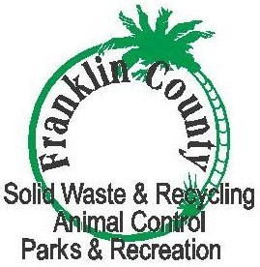

PUBLIC NOTICE

Please be advised that starting February 1, 2018, the Franklin County Central Landfill Tipping Fees will be as Follows:

Household Waste $65.00 Per Ton
Yard Trash $45.00 Per Ton
Construction & Demolition $65.00 Per Ton
White Goods $65.00 Per Ton
Regular Tires $ 2.50 Each (up to 4)
Large Truck Tires $ 5.00 Each
Tires/Over 4 $250.00 Per Ton
Seafood Waste $17.00 Per Ton

For more information, contact the Franklin County Central Landfill at 850-670-8167
or fcsh@fairpoint.net

